| Cybersecurity |
| --- |
| Module 7 Challenge Submission File |

## Active Directory Domain

Make a copy of this document to work in, and then for each step, add the solution commands below the prompt. Save and submit this completed file as your Challenge deliverable.

# Task 1:

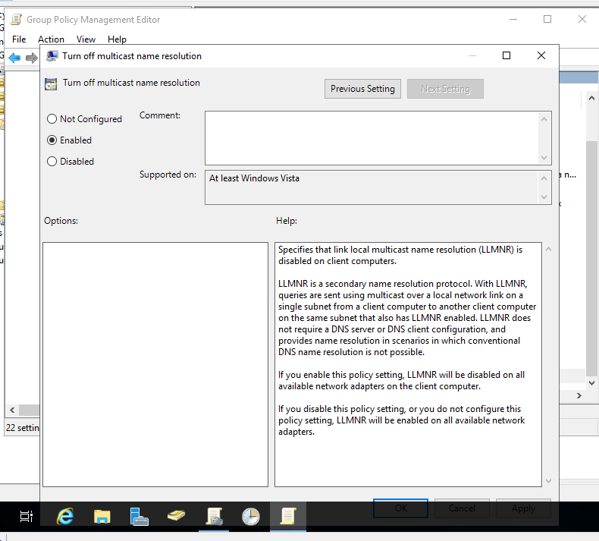

# Task 2:

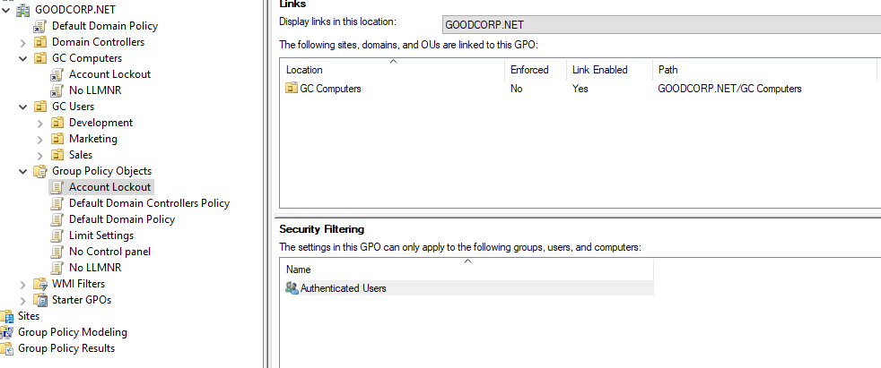  
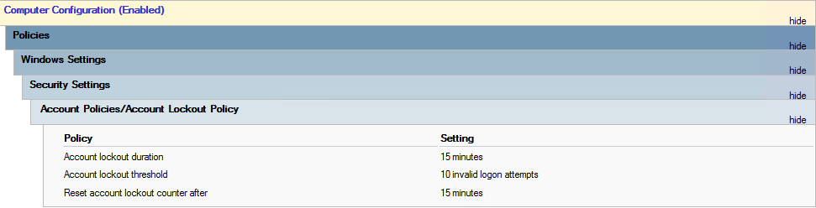  
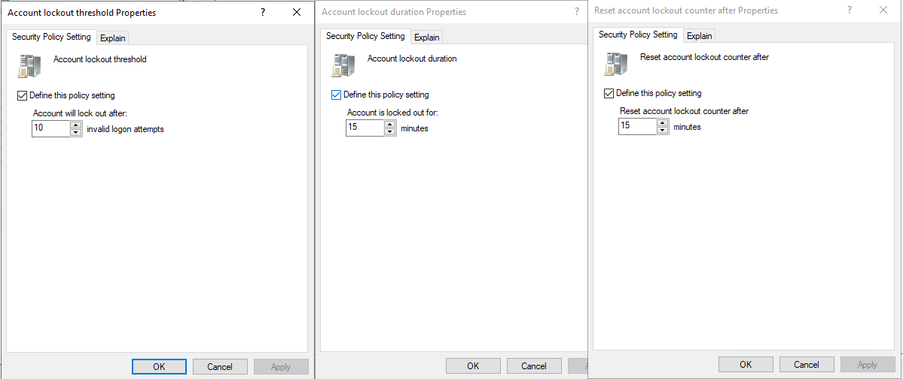

# Task 3:

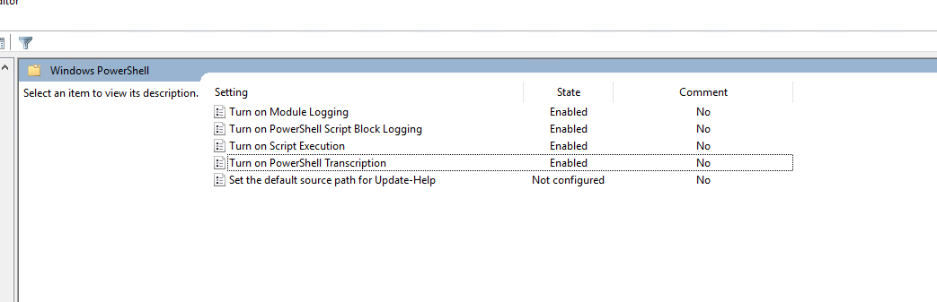

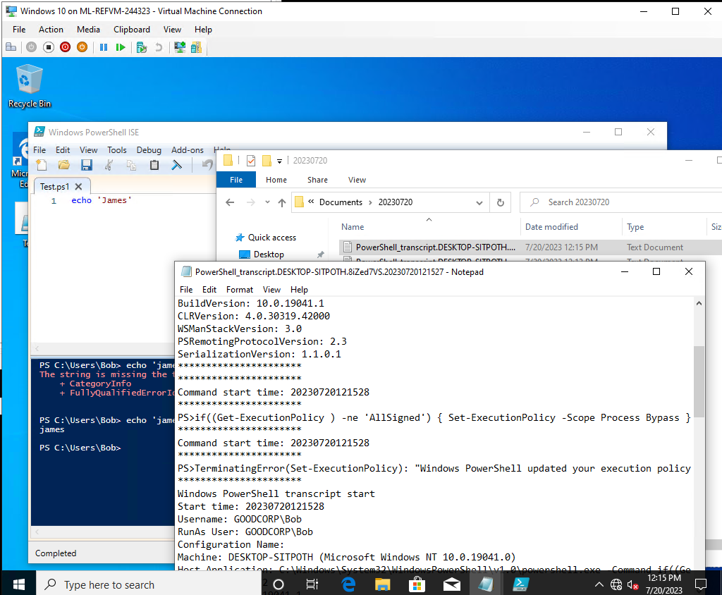

# Task 4:

$directory = Get-ChildItem

foreach ($item in $directory) {

Write-Output 'ACL Results for '$item': '

Get-ACL $item | Format-List

}

Write-Output 'ACL Exported Successfully of below files: '$directory''

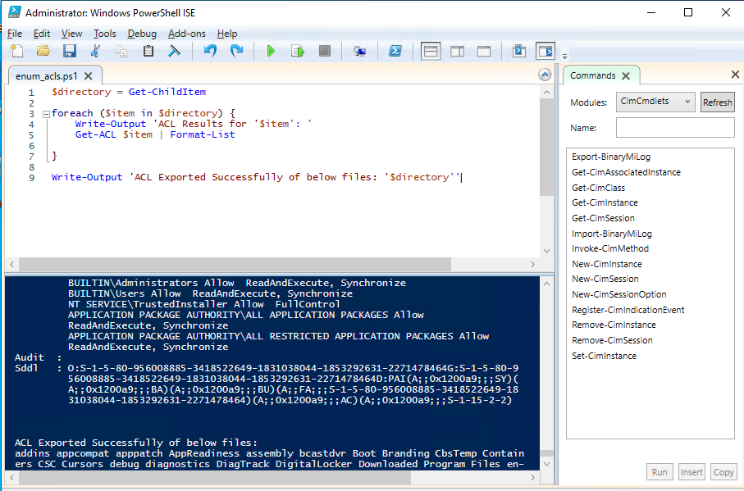

# Task 5: